AWS DIRECTORY SETUP STEP-BY-STEP GUIDE

1. Access to the AWS account/subscription where the Active Directory will be hosted.
2. Select the Directory Service in AWS console:

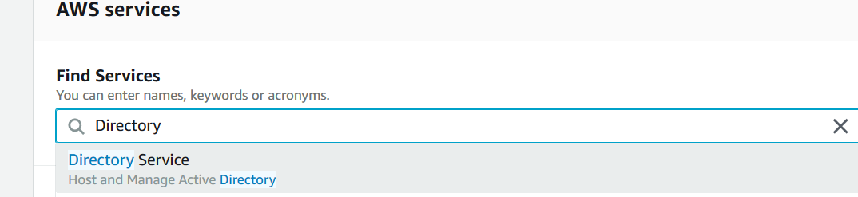

1. Click on setup Directory:

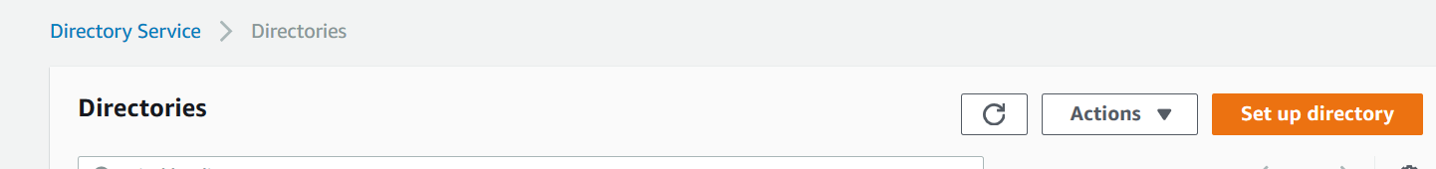

1. Select the Directory type: (usually AWS Managed Microsoft AD)

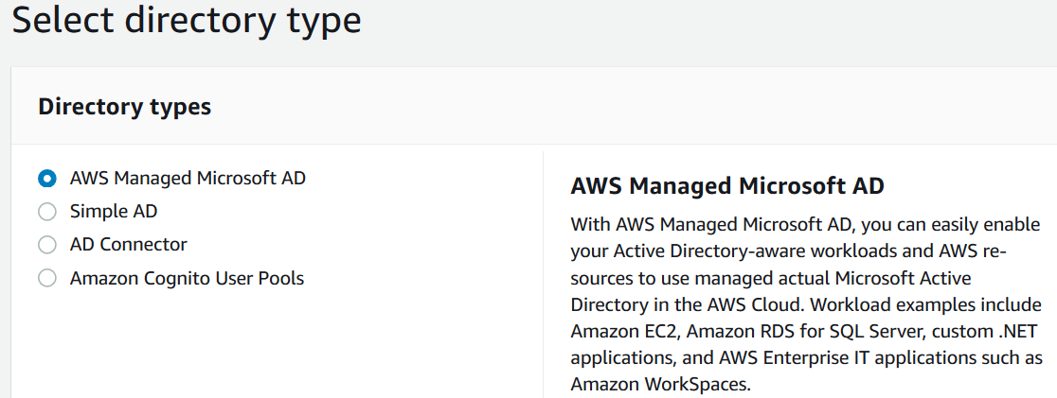

1. Click on Next and introduce the directory details and the Edition depending on the capacity:

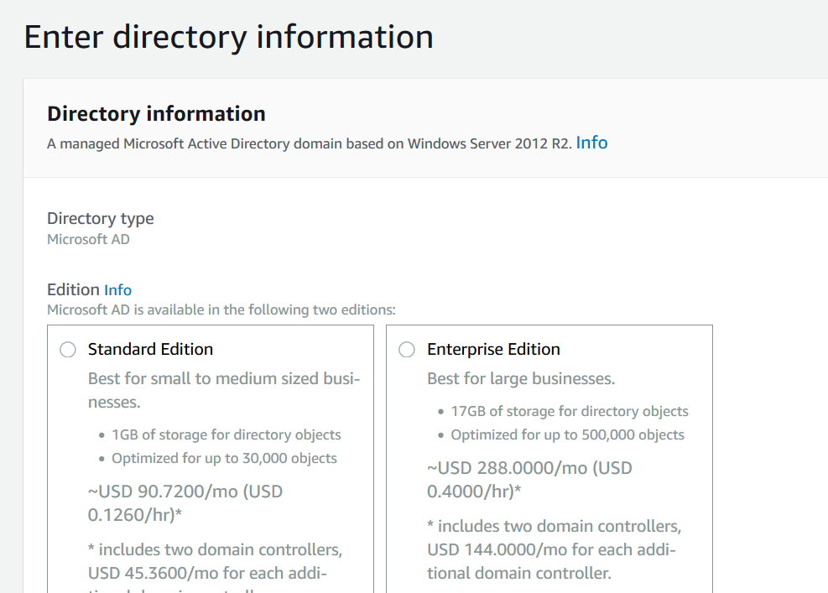

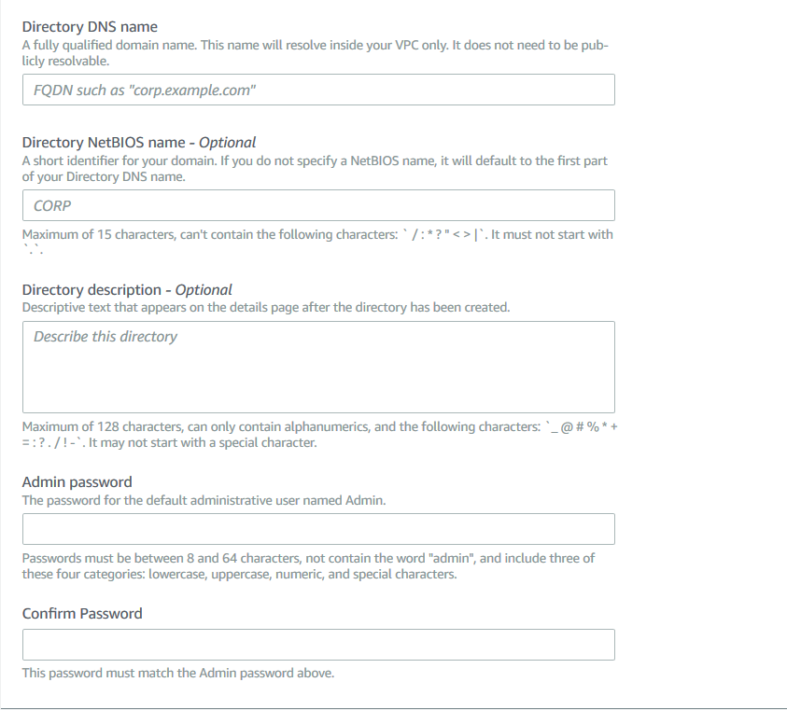

Username will be “Admin” and the password that you introduce.

1. Click on Next and select the VPCs and the subnet to host Active Directory.
2. Finally review and launch the creation.
3. The directory will be listed in the directories:

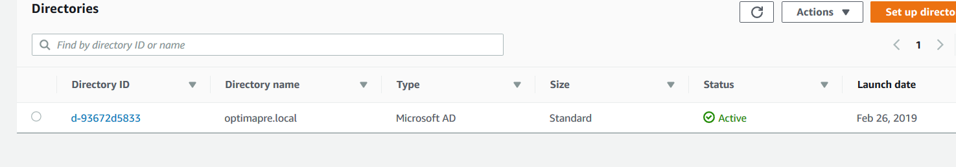

1. And you have access to the directory details:

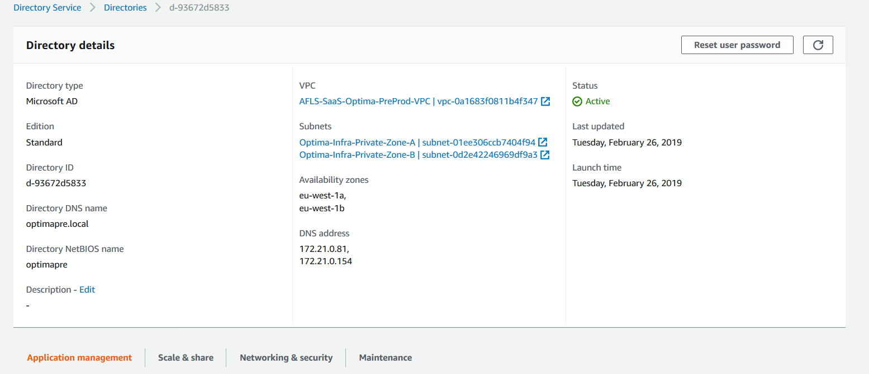

DNS address are listing the domain controllers but you need to access from a Windows VM with the AD tools.